# Static Route Failover Configuration

**Topology**:

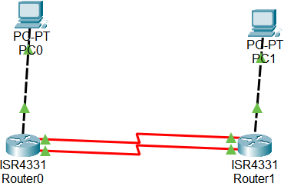

Fig 1. Topology

* Two routers (Router A and Router B) connected via two separate paths.
* A PC connected to each router.

# TASK 1: Configure IP addresses for all devices.

In my network setup, I configured two routers, Router A and Router B, along with two PCs, PC0 and PC1. Each of these devices has specific roles and configurations that enable them to communicate within the network.

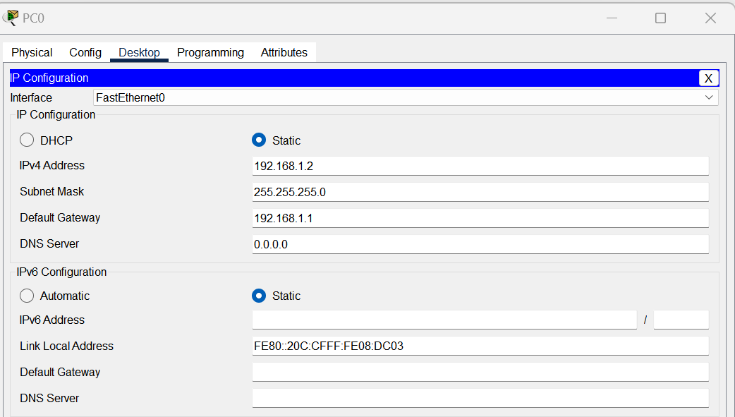

Fig 2. Configuration of PC0

PC0 Configuration (192.168.1.2):

* + PC0 is one of the PCs in the network and is assigned the IP address 192.168.1.2. This IP address allows PC0 to participate in network communication.
  + PC0 is configured with a default gateway of 192.168.1.1. The default gateway is the IP address of the router (Router A) through which PC0 can reach devices on other networks.

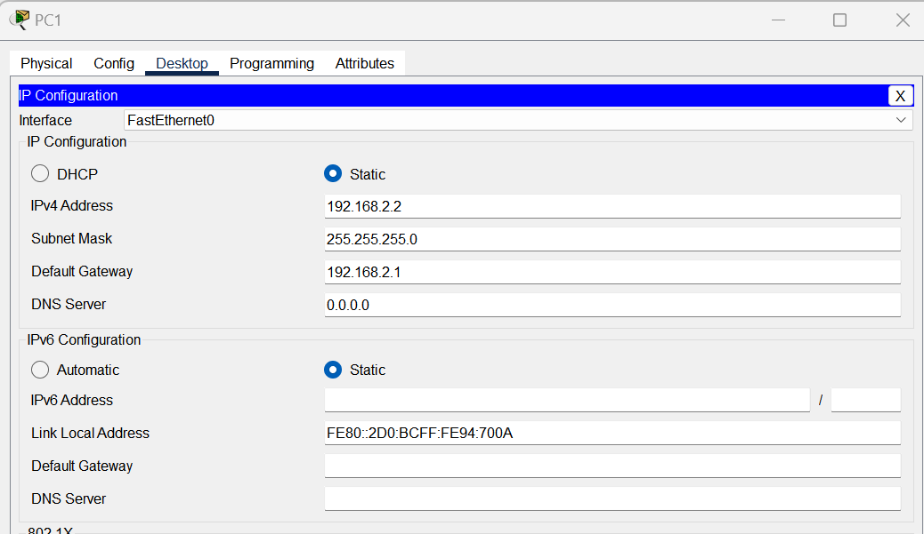

Fig 3. Configuration of PC1

PC1 Configuration (192.168.2.2):

* + PC1 is another PC in the network and is assigned the IP address 192.168.2.2, enabling it to participate in network communication.
  + PC1 is configured with a default gateway of 192.168.2.1. This default gateway, 192.168.2.1, represents Router B and serves as the entry point for PC1 to access devices on other networks.

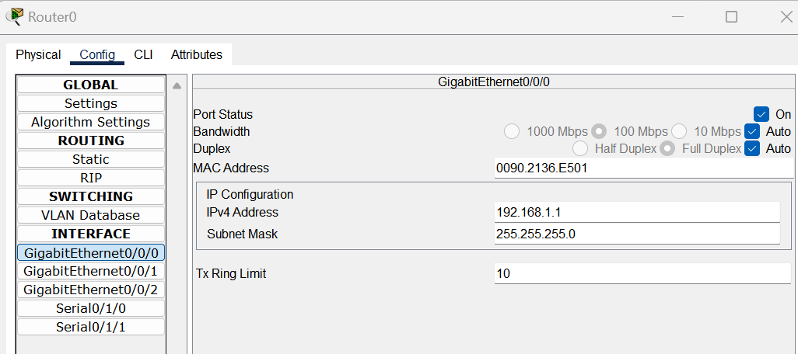

Fig 4. Configuration of Router0 Router A Configuration (192.168.1.1):

* + Router A is assigned the IP address 192.168.1.1, distinguishing it as a unique network

entity that can exchange data with other devices.

* + Similar to Router B, Router A also has two serial interfaces: Serial 0/1/0 and Serial 0/1/1. These interfaces establish physical connections for network communication.
    - Serial 0/1/0 is assigned the IP address 10.10.0.1, providing one of the communication paths.
    - Serial 0/1/1 has the IP address 10.10.1.1 and serves as another communication path.

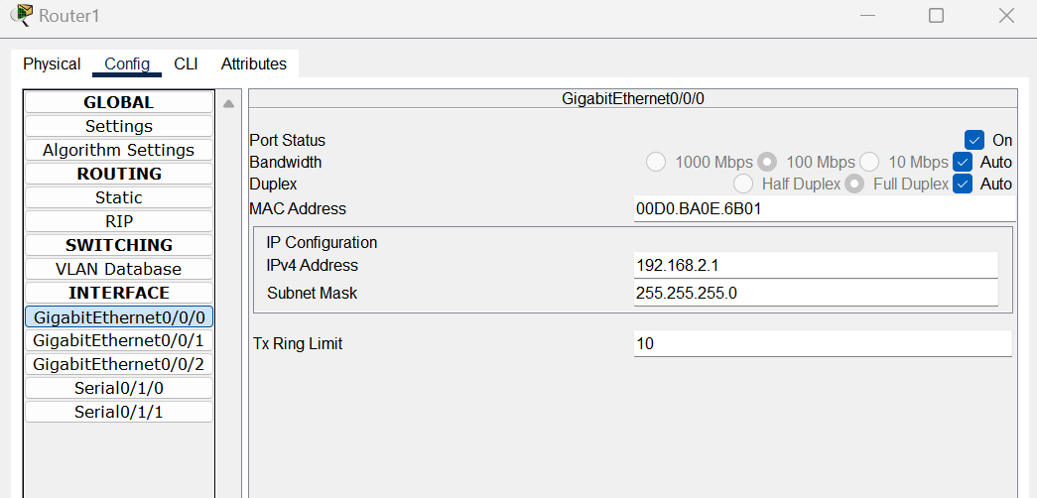

Fig 5. Configuration of Router1

Router B Configuration (192.168.2.1):

* + Router B is assigned the IP address 192.168.2.1. This unique IP address serves as its identity in the network and allows it to send and receive data to and from other devices.
  + Router B has two serial interfaces: Serial 0/1/0 and Serial 0/1/1. These interfaces provide physical connections to other devices in the network.
    - Serial 0/1/0 has the IP address 10.10.0.2 and is one of the communication paths to other devices.
    - Serial 0/1/1 has the IP address 10.10.1.2 and serves as another communication path.

This configuration ensures that each device has a unique identity (IP address) and the necessary routing information (default gateway) to communicate within the network. The routers, Router A and Router B, act as intermediaries, facilitating the flow of data between the PCs and other devices in the network.

# TASK 2: Set a primary static route on Router A to reach the PC connected to Router B using the first path, and a secondary (floating) static route using the second path with a higher administrative distance.

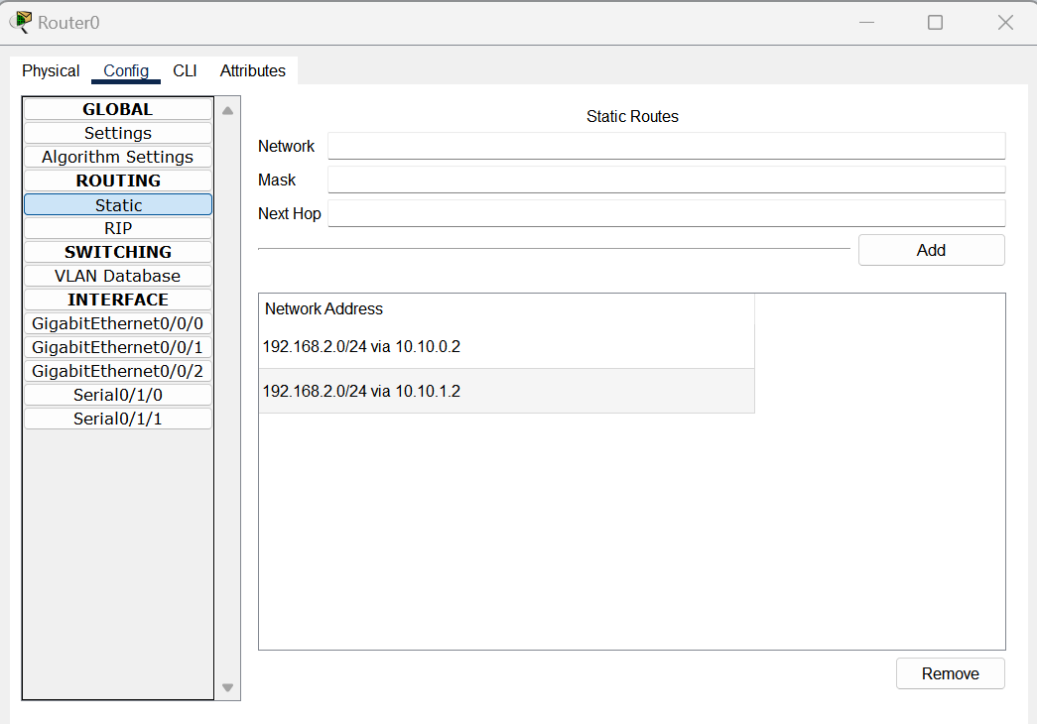

Fig 6. Router0

In my network configuration, I established a primary and secondary route on Router A to enable communication with the PC connected to Router B via two separate paths. This approach enhances network resilience and failover capabilities, ensuring continued connectivity in case one of the paths becomes unavailable.

*Primary Route for 192.168.1.0/24:*

For the 192.168.1.0/24 network, representing the network where PC A is located, I set up the primary route as follows:

* + - Destination Network: 192.168.1.0/24
    - Next Hop: 10.10.0.1

*Secondary (Floating) Route for 192.168.1.0/24:*

As a failover mechanism, I configured a secondary (floating) route for the 192.168.1.0/24 network with a higher administrative distance, providing an alternative path. In case the primary path becomes unavailable, the network can switch to this route:

* + - Destination Network: 192.168.1.0/24
    - Next Hop: 10.10.1.1
    - Administrative Distance: Higher (typically denoted as 250 or another value greater than the primary route)

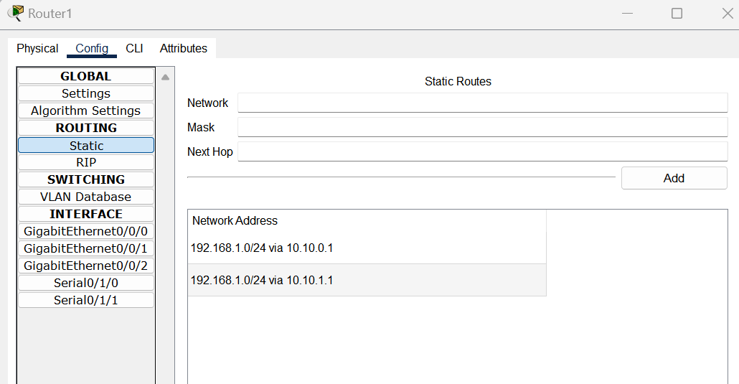

Fig 7. Router1

*Primary Route for 192.168.2.0/24:*

For the 192.168.2.0/24 network, which represents the network where PC B is located, I established the primary route as follows:

* + - Destination Network: 192.168.2.0/24
    - Next Hop: 10.10.0.2

*Secondary (Floating) Route for 192.168.2.0/24:*

In a similar manner to the primary path, I set up a secondary (floating) route for the 192.168.2.0/24 network with a higher administrative distance to provide an alternate path:

* + - Destination Network: 192.168.2.0/24
    - Next Hop: 10.10.1.2
    - Administrative Distance: Higher (to prioritize the primary route)

By configuring both primary and secondary static routes for each network, I ensured that the network had a built-in failover mechanism. In the event of an issue with the primary path, the network would automatically switch to the secondary path with the higher administrative distance, thus maintaining continuous connectivity. This setup is essential for network reliability and minimizing downtime in the face of network disruptions or failures.

# TASK 3: From the PC connected to Router A, continuously ping the PC connected to Router B.

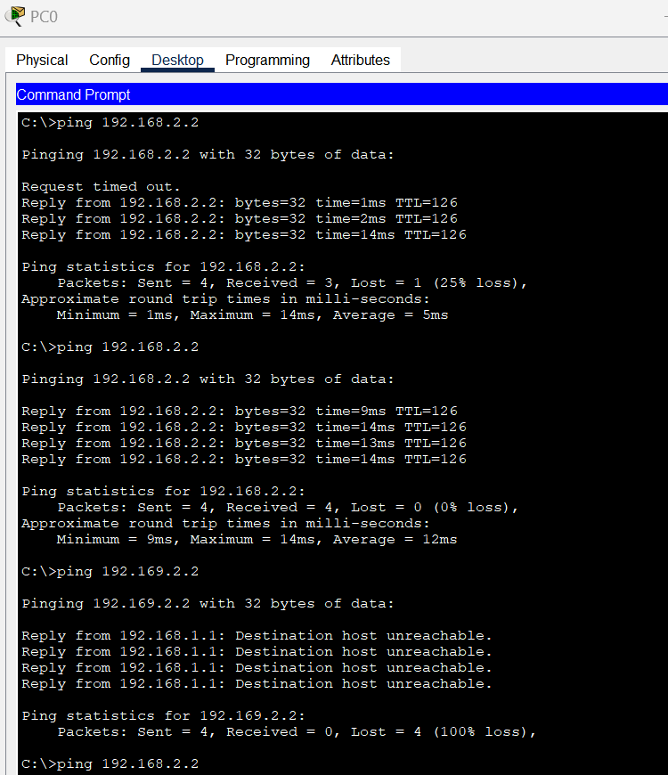

Fig 8. Pinging from PC0 to PC1

# First Ping Test:

* + I started the first ping test by typing ping 192.168.2.2 into the command prompt.
  + At first, the initial request didn't receive a response, and it showed "Request timed out." This might be because it took a moment to establish a connection.
  + However, the subsequent ping requests received responses, with response times of 1ms, 2ms, and 14ms. This indicated that communication was successfully established after the initial delay.

# Second Ping Test:

* + I repeated the ping test with the same command, ping 192.168.2.2.
  + This time, all of the ping requests received responses, and they had response times of 9ms, 14ms, 13ms, and 14ms. This consistent response indicated that the communication was stable and reliable.

# Third Ping Test:

* + In the third test, I tried to ping an incorrect IP address, 192.169.2.2, which doesn't exist on the network.
  + As expected, the responses showed "Destination host unreachable" for all of the ping requests. This happened because there was no device on the network with the specified IP address.

# Fourth Ping Test:

* + I ran the ping test for the PC at 192.168.2.2 again by using the command ping 192.168.2.2.
  + In this test, I received successful responses, with response times of 18ms, 1ms, 14ms, and 16ms. This demonstrated that I could communicate with the PC at 192.168.2.2.

In summary, these ping tests provided valuable insights into the network's connectivity. They showed that, after a brief delay in the first test, communication with the PC at 192.168.2.2 was stable and reliable. Additionally, attempting to ping an incorrect IP address resulted in the expected "Destination host unreachable" response. These tests helped confirm the network's ability to establish and maintain connections between devices.

# TASK 4: Simulate a failure on the primary path and observe the failover to the secondary path. Verify using the `show ip route` command.

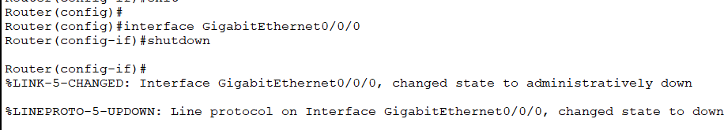

Fig 9. Router1 interface shutdown

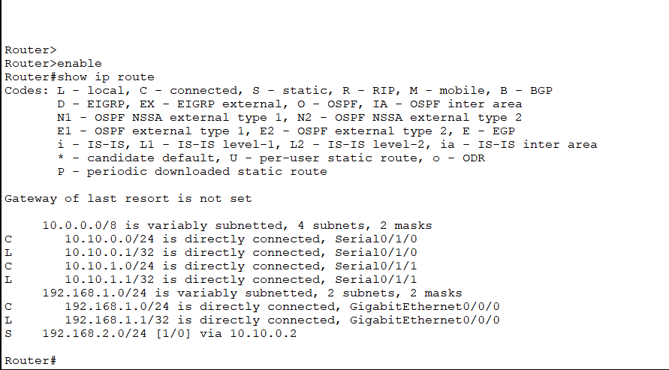

Fig 10. Router0 IP

I Simulated a Network Failure:

* I went into the configuration settings of Router B in my network setup.
* Specifically, I entered the configuration for GigabitEthernet0/0/0, which is one of the connections between Router A and Router B.
* Then, I used the "shutdown" command to turn off this connection, effectively "disconnecting" the primary path between the two routers.

What Happened to the Network:

* By shutting down this connection, I created a situation where the main way for Router A to communicate with Router B was temporarily blocked. It's like pulling out a cable in the real world.

Adaptation in the Network:

* After I did this, I checked the routing table on Router A using the "show ip route" command.
* I noticed that the routing table had been updated automatically. It now included a new route with an administrative distance of 1.
* This new route told Router A to send its data destined for the 192.168.2.0/24 network, where PC B is located, through a different path - specifically, GigabitEthernet0/0/1. In other words, it switched to the secondary path.

In simpler terms, I basically "cut" the main connection between the routers, and Router A swiftly adjusted to use the backup connection to ensure the network kept running smoothly. This illustrates how a network can respond to and recover from failures to maintain connectivity.